February 4, 2014
Vocal Competition Announcement
The Dallas Opera Guild is honored to host the 26th Annual Vocal Competition on March 15, 2014 at the Margot and Bill Winspear Opera House located at 2403 Flora Street, Dallas Texas 75201. The Competition is open to classically trained singers between the ages of 18 and 30 who have a Texas connection: by birth, training or current residence.
Preliminary judging selected 21 applicants to participate as semi-finalists. These semi-finalists will compete in the Margaret McDermott Performance Hall in the Margot and Bill Winspear Opera House. The semi-finalists are as follows:

Erin Alcorn, Soprano
Cristina Bakhoum, Mezzo-Soprano
Christopher Besch, Bass-Baritone
Nicholas Brownlee, Bass-Baritone
Bille Bruley, Tenor
Natalie Cummings, Soprano
Rebekah Howell, Soprano
Moretta Irchirl, Mezzo-Soprano
Youna Jang, Soprano
Sooyeon Kang, Soprano
Jeawook Lee, Tenor
Natalie Logan, Soprano
Trevor Martin, Baritone
Audra Methvin, Soprano
Sarah Clementine Mire, Soprano
Chaazi Munyanya, Mezzo-Soprano
Said Henry Pressley, Bass-Baritone
Coretta Smith, Soprano
Reginald Smith, Jr., Baritone
Matthew Stump, Baritone
Brent Turner, Baritone

Semi-finals begin at 11:30 A.M.; finals at 7:30 P.M. By offering free admission to the event, the Competition enriches lovers of the arts through enhanced cultural opportunity, awareness, and access to a live performance in an acclaimed opera house. Come and enjoy the art of the aria and the exceptionally high level of musical and artistic achievement. Through the increased exposure the Competition provides, the Guild endeavors to build future audiences for the opera, as well as performance opportunities for the contestants. Through their achievements, contestants draw recognition to the quality of the vocal arts in Texas and/or the Texas universities at which they studied.
Vote for the singer of your choice through the People’s Choice Award. There will be boxes in the lobby with the name of your favorite finalist, just drop your ballot in!
Please support them by attending on March 15. Free admission. Parking is $5. Enjoy a day of exhilarating, gorgeous music. You won’t be disappointed!
Sincerely,

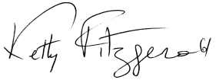
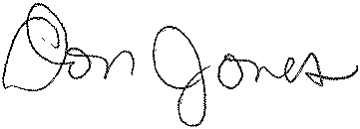
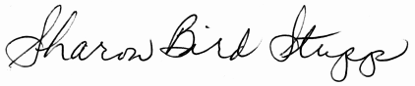
Sharon Bird Stupp, Chairman Ketty Fitzgerald, Co-Chair Don Jones, Contestant Chair
Vocal Competition Vocal Competition Vocal Competition

